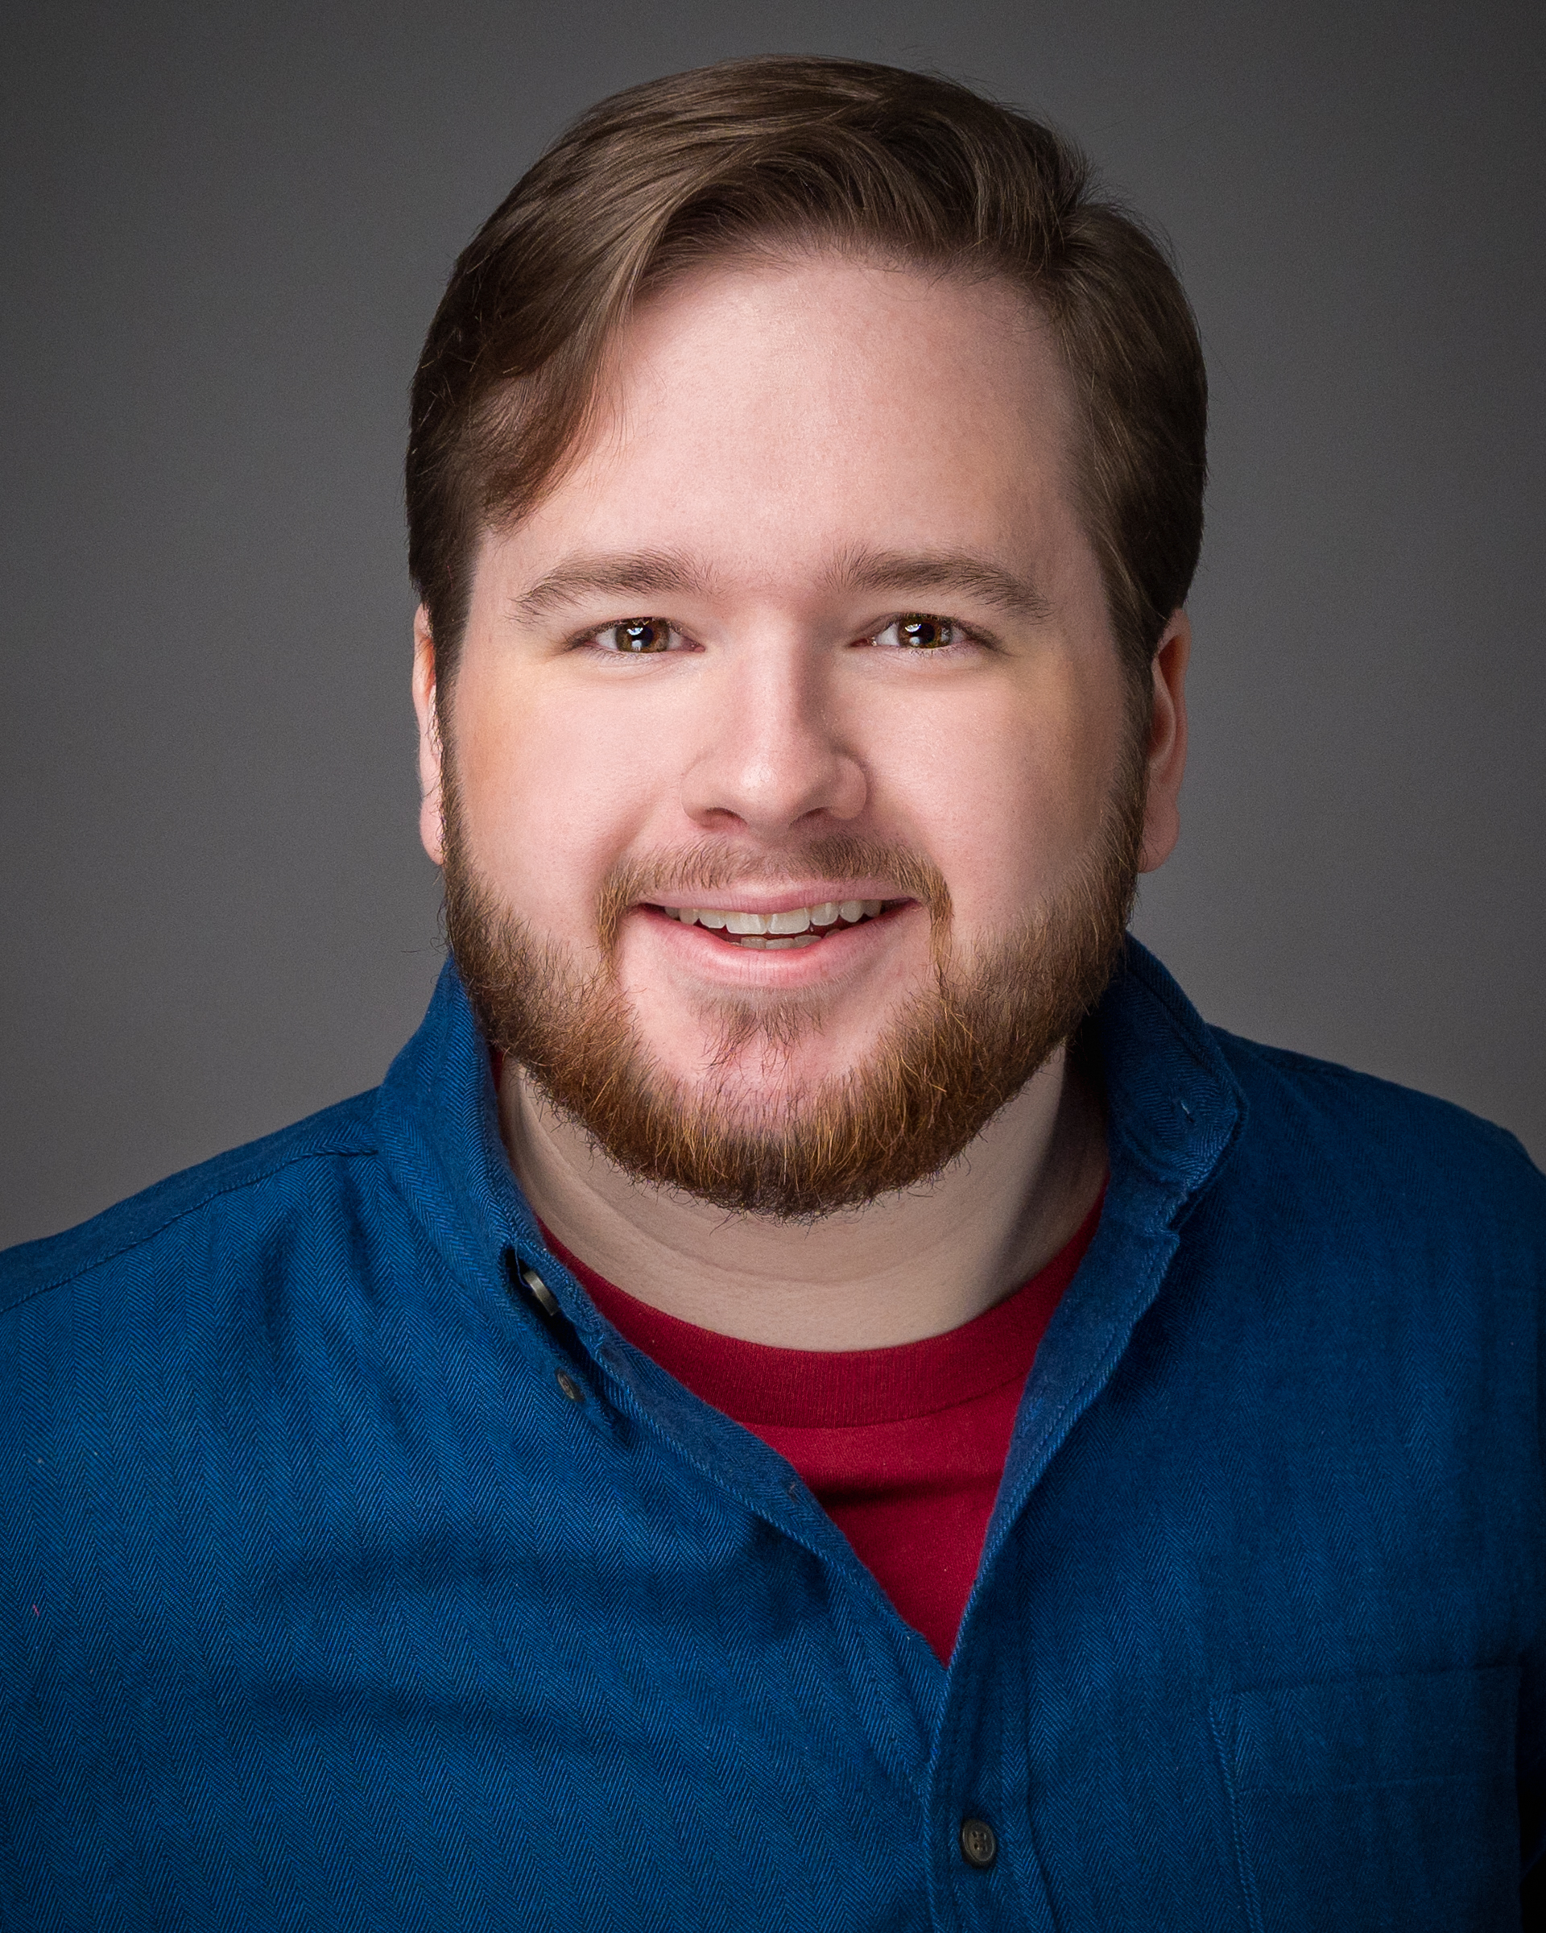
ALEXANDER
RYBITSKI
alexander.rybitski@gmail.com
Hair: Brown ⋅ Eyes: Brown ⋅ 5’8”
NEW MEDIA
Man On The Internet/YouTube Cast Member Alex Beckham
Undertale: The Musical Flowey Alex Beckham
Chrono Trigger: The Musical Chancellor / Ozzie Alex Beckham
THEATRE
Broken Hands Gervaise Ollivander; Ensemble Nigel Semaj Barnes
Maryanne Voice Barbara McGlammery
Almost, Maine Chad / Dave Leigh Anne Jensen
Ophelia Player Chris Russel
Macbeth Captain / Porter / Apparition Jeremy Goldson

MUSICAL THEATRE
You’re A Good Man Charlie Brown Linus Great Hall Theatre

SHORT FILM
Burnsville Dan from HR Allie Fuller
TRAINING
New York Conservatory for Dramatic Arts – 2 years, Associates in Occupational Studies (Film & Television)
Vocal Training – Kristen Samu – Music Theatre (3 years)
Voice Over – Lane Binkly, Nick Cianfrogna
Movement – Karl Maier, Donnie Mather, Laura Butler
On-Camera – Rawleigh Moreland, Abigail Zealy Bess, Amy van Horn
Improv – Suzanne Hevner
Voice Acting Mastery Online Class – Crispin Freeman
Voice Performance Coaching – Orion Acaba
SPECIAL SKILLS
Dialect: British RP, Estuary, German, Irish; US Passport & Driver’s License; Vocal Range A2 to C5 (F4 Break); Dungeons & Dragons; Absurd finger popping.

